
(An Autonomous Institution, Affiliated to Anna University, Chennai)
MINI PROJECT
TOURISM ANALYTICS AND VISUALIZATION USING POWER BI
Framework for Data Visual Analytics

CHAIRAM R

241501036
ABSTRACT
This mini project, carried out for the subject Framework of Data Visualization and Analytics (FDVA), presents a Tourism Analytics dashboard created in Microsoft Power BI. The dashboard summarizes visitor volume, tourism revenue, location availability, country-wise performance, category-wise visitors and accommodation availability. It uses KPI cards, slicers and multiple visualizations to make tourism information easier to explore. The report describes the key indicators and charts visible in the dashboard screenshot. The displayed figures include approximately 3bn total visitors, 2.99bn total revenue, 6K total locations and an average revenue of 499.48K. The dashboard supports comparisons across countries and tourism categories and helps users identify patterns in visitor activity and revenue.

1. Tourism Dashboard Overview
The Tourism Analytics dashboard presents tourism-related indicators in a single interactive Power BI report. It combines summary cards, filters and charts to provide an overview of visitors, revenue and locations.

Key performance indicators

Total Visitors = 3bn
Total Revenue = 2.99bn
Total Locations = 6K
The KPI cards provide a quick overview of visitor volume, total revenue and the number of tourism locations represented in the report.

Dashboard filters

Country slicer: Egypt, Australia, Brazil, China, Egypt, France, India and USA
Category slicer: Adventure, Beach, Cultural, Historical and Nature
The country and category slicers allow users to narrow the report to selected locations or tourism types. Selecting a filter updates the related visuals on the page.

Reading the dashboard

Visitors and revenue
Location availability
Accommodation availability
The dashboard uses different chart types to present the same tourism dataset from multiple angles. KPI cards summarize totals, while charts compare country and category performance.
The displayed measures should be interpreted in the context of the filters currently selected in Power BI.

The dashboard is designed to make large tourism figures easier to compare and explore. Its interactive filters support focused analysis without requiring users to inspect individual records.

Visual analysis

Country-wise visitor comparison
Category-wise visitor distribution
Revenue comparison
The country-wise bar chart compares visitor totals across the countries shown in the report. The category chart shows how visitors are distributed among tourism categories.
The category labels include Adventure, Urban, Historical, Cultural, Beach and Nature, as visible in the dashboard.
The visuals provide a quick way to compare visitor counts and revenue across selected groups. Exact values depend on the filters and the underlying dataset.

Accommodation availability

Accommodation availability = Yes / No
The donut chart divides the 6K locations by accommodation availability. The two segments appear close in size, indicating a fairly balanced split between available and unavailable accommodation.
Visitors by category
Revenue by country
The category donut chart summarizes visitor volume by tourism category. The country revenue chart compares the revenue contribution of the countries displayed.
The dashboard also includes a scatter plot relating rating to visitor volume, allowing users to inspect how visitor counts vary across rating values.

Summary indicators

Total Visitors = 3bn
Total Revenue = 2.99bn
Average Revenue = 499.48K
These measures provide a compact summary of the dashboard. The average revenue card complements the total revenue KPI by showing the displayed average measure.

2. Visualizations in Power BI
The dashboard combines bar charts, donut charts, a scatter plot and KPI cards. The figures below describe the visualizations visible in the uploaded Tourism Analytics dashboard screenshot.
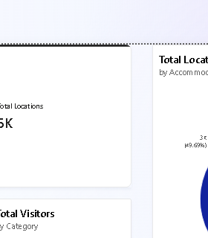
Figure 2.1: Total revenue by country (bar chart)
The bar chart compares revenue across countries including Egypt, India, USA, Brazil, Australia, France and China. The displayed bars range from approximately 0.40bn to 0.46bn.
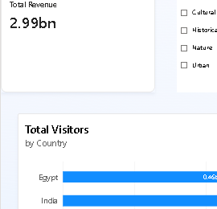
Figure 2.2: Total visitors by country (horizontal bar chart)
The horizontal bar chart compares visitor totals by country. The visible values are close to one another, with Egypt, India and the USA among the leading countries.
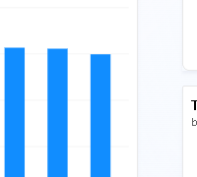
Figure 2.3: Total visitors by category (donut chart)
The donut chart shows visitor distribution across tourism categories, including Adventure, Urban, Historical, Cultural, Beach and Nature.
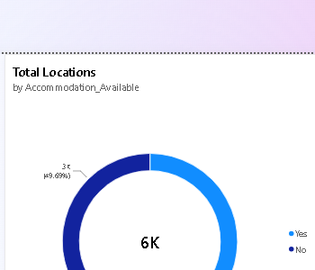
Figure 2.4: Locations by accommodation availability (donut chart)
The 6K locations are divided into Yes and No accommodation-availability groups, with the two portions appearing approximately equal.
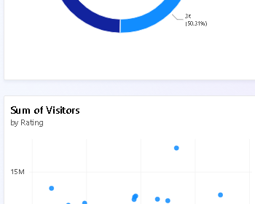
Figure 2.5: Visitor rating distribution (scatter plot)
The scatter plot compares Rating on the horizontal axis with Sum of Visitors on the vertical axis. Points are spread across ratings from 1 to 5, with most visitor totals clustered in the middle range.
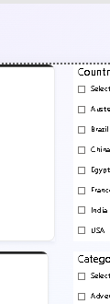
Figure 2.6: Country and category filters
The slicers allow users to focus on specific countries or tourism categories and inspect how the dashboard values change.
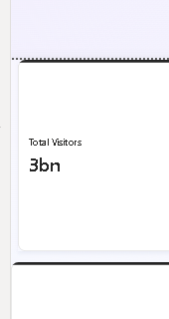
Figure 2.7: KPI cards
The key cards display Total Visitors (3bn), Total Revenue (2.99bn), Total Locations (6K) and Average Revenue (499.48K).
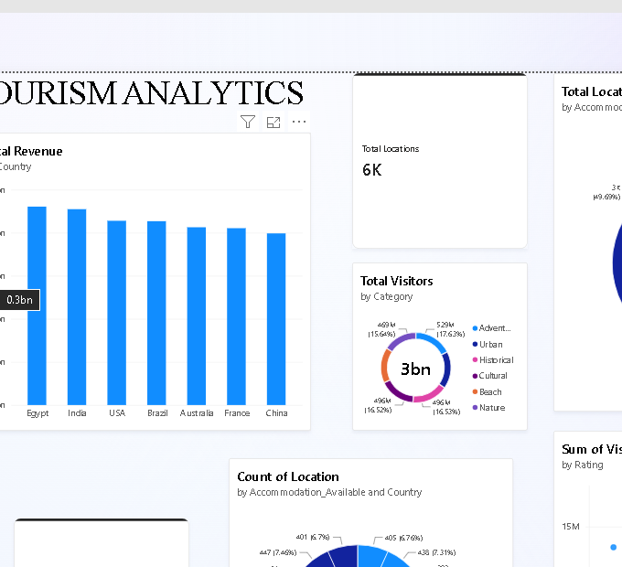
Figure 2.8: Tourism Analytics dashboard overview
The dashboard brings the indicators and charts together on one page, supporting quick comparisons between visitor volume, revenue, location availability and rating.
Overall, the dashboard presents a high-level view of tourism activity. Country and category filters help users explore the figures, while the charts reveal relative differences among countries, categories and ratings.

3. Power BI Dashboard
Microsoft Power BI was used to create a one-page Tourism Analytics dashboard from the tourism data.
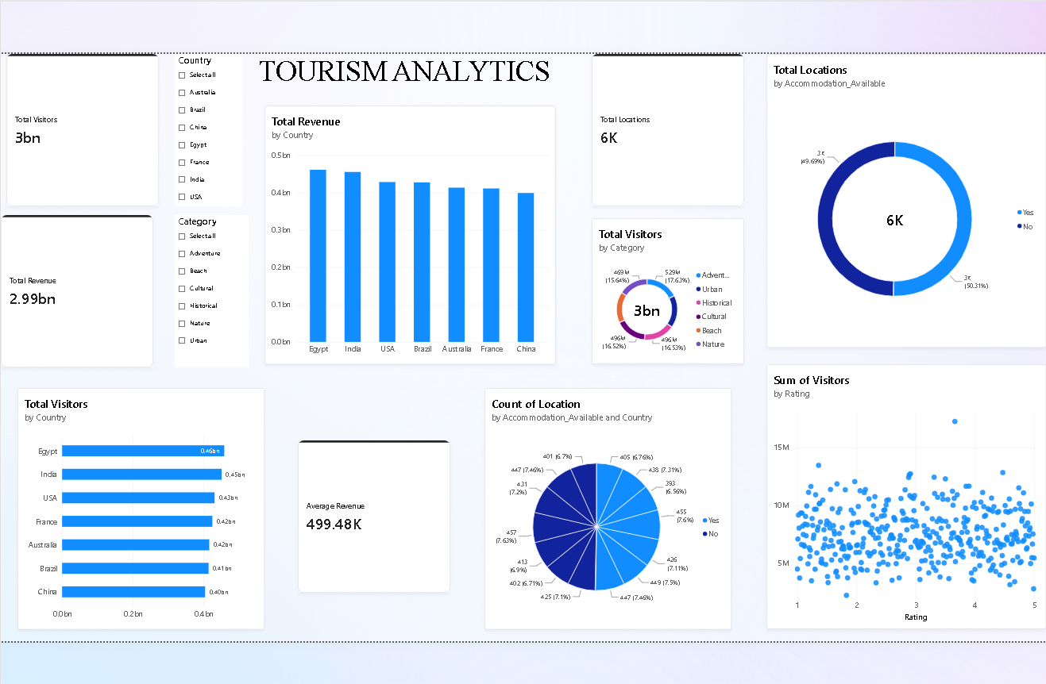
Figure 3.1: Tourism Analytics Dashboard in Power BI
- Filters: Country and Category slicers let users focus on selected countries and tourism categories.
- KPI cards: Total Visitors 3bn, Total Revenue 2.99bn, Total Locations 6K and Average Revenue 499.48K.
- Charts: total revenue by country, total visitors by country, visitors by category, locations by accommodation availability and visitors by rating.
- Insights: the country revenue bars are relatively close in height; accommodation availability is split into two similarly sized groups; visitor totals vary across ratings.
- Note: values shown are the figures visible in the uploaded dashboard screenshot and may change when slicers are applied.

4. Dashboard Findings
The Tourism Analytics dashboard combines summary indicators and interactive charts to support exploration of visitor activity and tourism revenue.
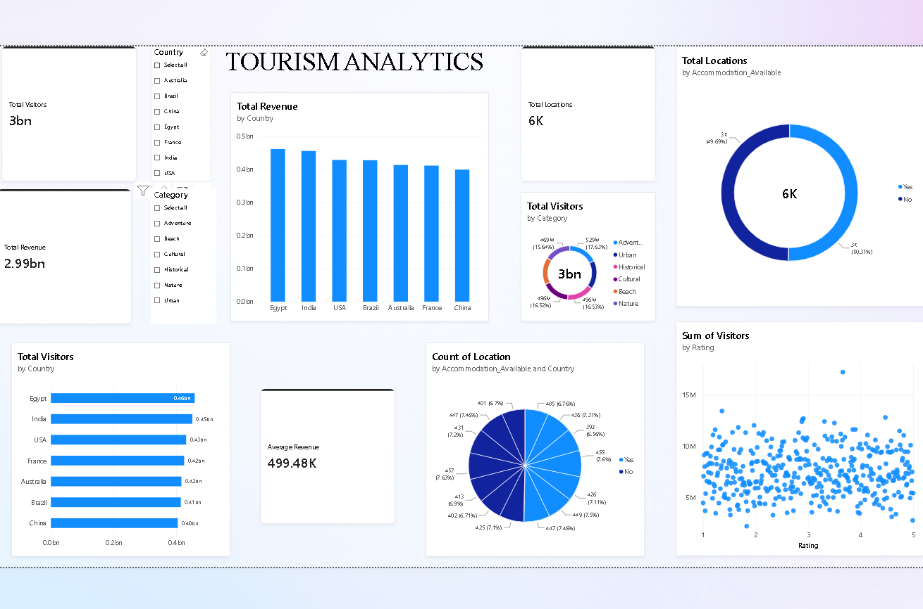
Figure 4.1: Tourism Analytics Dashboard
- Filters: Country and Category.
- KPIs: Total Visitors 3bn, Total Revenue 2.99bn, Total Locations 6K and Average Revenue 499.48K.
- Charts: revenue by country, visitors by country, visitors by category, accommodation availability and visitors by rating.
- Findings: country-level revenue is comparatively close across the displayed countries, accommodation availability is nearly balanced, and the scatter plot shows a broad spread of visitor totals across ratings.

